1. PRINT HELLO WORLD

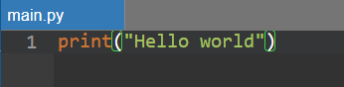

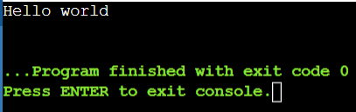

1. PROGRAM TO READ INPUT FROM USER

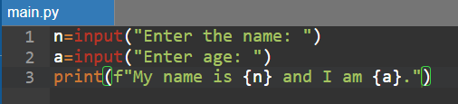

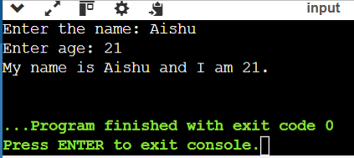

1. WRITE A PROGRAM TO ENTER A NUMBER AND DISPLAY ITS HEX AND OCTAL EQUIVALENT AND ITS SQUARE ROOT

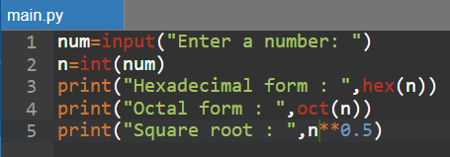

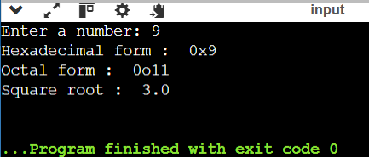

1. WRITE A PROGRAM TO CALCULATE AREA OF A TRIANGLE USING HERON’S FORMULA

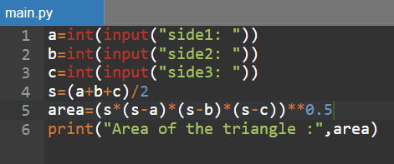

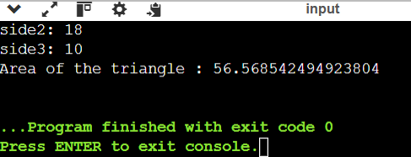

1. WRITE A PROGRAM TO CALCULATE THE DISTANCE BETWEEN TWO POINTS

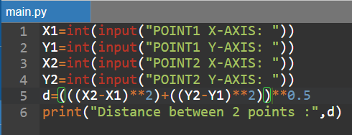

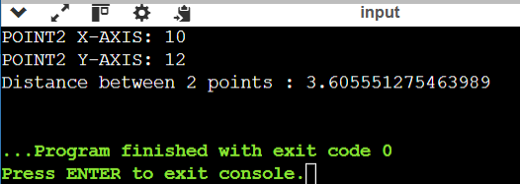

1. WRITE A PROGRAM TO PRINT THE DIGIT AT ONE’S PLACE OF A NUMBER

